Project Design Phase-II Technology Stack (Architecture & Stack)

Date | 20 February 2026
Team ID | LTVIP2026TMIDS24635
Project Name | Flight finder-navigating your air travel options
Maximum Marks | 4 Marks

Technical Architecture:
The Deliverable shall include the architectural diagram as below and the information as per the table1 & table 2
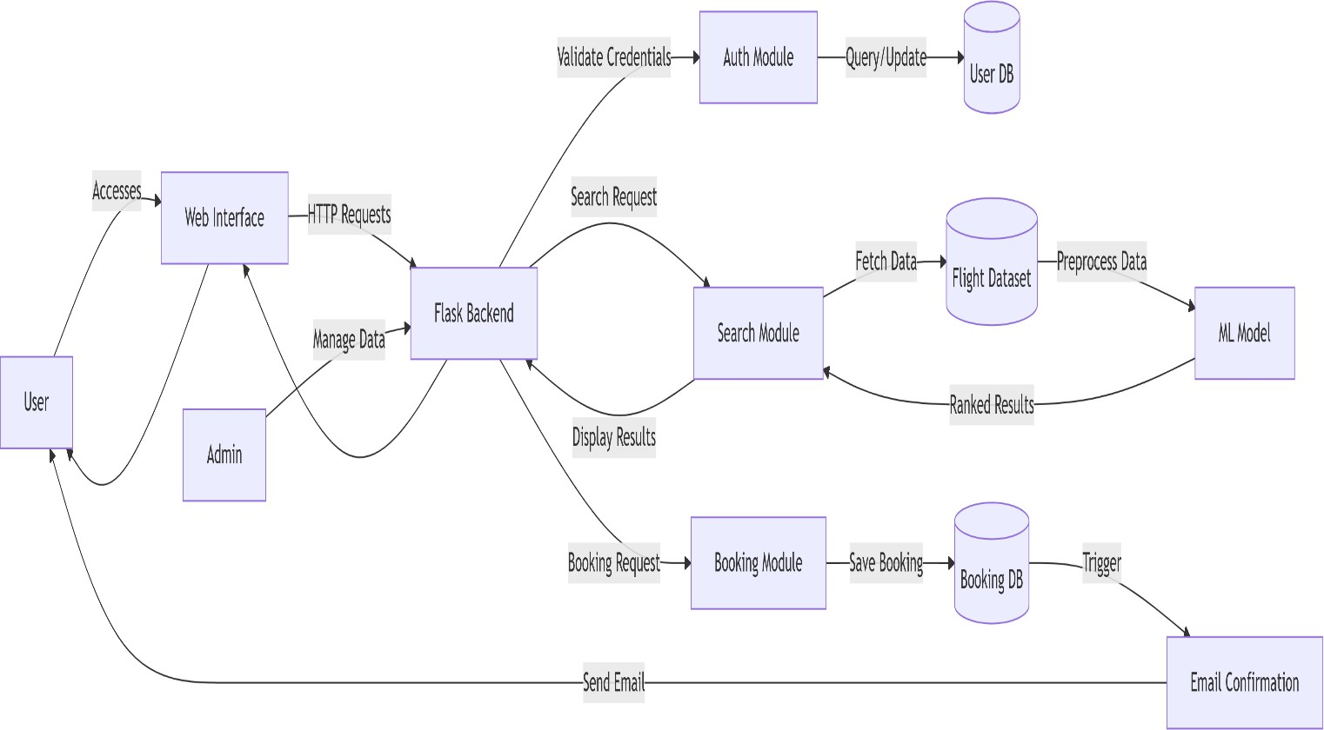
Table 1: System Components and Technology Stack

S.No | Component | Description | Technology
1. | User Interface | Web interface for users, flight agencies, and admin to interact with the system | HTML, CSS, JavaScript, Bootstrap / React JS
2. | Application Logic-1 | Backend logic for user registration, login, flight search, booking, and confirmations | Python (Flask) / Java
3. | Application Logic-2 | Business logic for flight agency registration, flight addition, and updates | Python (Flask)
4. | Application Logic-3 | Admin logic for approving agency accounts and flight listings | Python (Flask)
5. | Authentication & Authorization | User, agency, and admin authentication with role-based access | Flask Authentication / JWT
6. | Database | Stores user data, agency data, flight details, and booking records | MongoDB
7. | File Storage | Storage for flight datasets (CSV/Excel) and logs | IBM Block Storage or Other Storage Service or Local Filesystem
8. | External API-1 | Optional flight data integration (if live data is used) | Public Flight APIs (optional)
9. | External API-2 | Email notification service for registration and booking confirmation | SMTP / Gmail API
10. | Machine Learning Model | predict flight pricing or recommend best options | Python, Scikit-learn
11. | Infrastructure (Server / Cloud) | Hosting and deployment of the application | Local, Cloud Foundry, Kubernetes, etc.

Table-2: Application Characteristics:

S.No | Characteristics | Description | Technology
1. | Open-Source Frameworks | Uses open-source tools and libraries for development, data processing, and ML | Flask, Pandas, Scikit-learn, Bootstrap
2. | Security Implementations | Ensures secure authentication, authorization, and data protection | Password hashing (bcrypt), JWT, HTTPS, Flask-Login, Email verification
3. | Scalable Architecture | Modular design with clear separation of frontend, backend, and database layers | 3-tier architecture, Microservices used
4. | Availability | High availability via cloud hosting | Load balancing (Render, Heroku Dynos, etc.)

S.No | Characteristics | Description | Technology
5. | Performance | Efficient queries, ML model caching, optimized routing | MongoDB indexing, Python caching, CDN (optional)
6. | Reliability | Ensures consistent operation without data loss during failures | Transaction management, exception handling
7. | Maintainability | Easy to update, debug, and extend features such as new APIs or services | Modular Flask structure, MVC pattern
8. | Portability | Application can run on local systems or cloud environments | Localhost, Cloud platforms
9. | Data Management | Efficient storage and retrieval of user, agency, flight, and booking data | MongoDB
10. | Machine Learning Support | Supports price prediction and flight recommendation logic | Python, Scikit-learn

